JOURNAL OF SPACE SECURITY 2026, 1(1):00-00
https://doi.org/00.0000/JOSS.2026.1.1.1 ISSN (online) : 3058-5759
Research Article
Title: Font, Ocean Sans Std Semibold; Size, 15pt
First Author¹, Second Author², and Third Author¹*
¹Department of Aerospace Engineering, Seoul National University, Seoul 08826 South Korea
²Department of Aerospace Engineering, Indian Institute of Technology Madras, P.O., Chennai 600 036, India
*Corresponding author: Corresponding author e-mail
Received Monthly 00, 2026 / Revised February 00, 2026 / Accepted March 00, 2026
ABSTRACT
Abstract: Font, Minion Pro; Size, 9pt; Content style is applied.
Key Words: Font, Minion Pro; Size, 9pt; Capitalize the first letter of all keywords words.

1. INTRODUCTION

Apply body styles; Font, Minion Pro; Size, 10pt

2. MATERIALS AND METHODOLOGY

2.1. Subtitle: Font, Minion Pro SmBd; Size, 10pt; Location, Left
Apply body styles; Font, Minion Pro; Size, 10pt

© 2026 Korean Academy of Space Security
This is an Open Access article distributed under the terms of the Creative Commons Attribution Non-Commercial License (https://creativecommons.org/licenses/by-nc/4.0/) which permits unrestricted non-commercial use, distribution, and reproduction in any medium, provided the original work is properly cited.

3. RESULTS AND DISCUSSIONS

3.1. Subtitle: Font, Minion Pro SmBd; Size, 10pt; Location, Left
3.1.1. Smalls title: Font, Ocean Sans Std Book; Size, 10pt; Location, Left
Apply body styles; Font, Minion Pro; Size, 10pt

4. CONCLUSION

Apply body styles; Font, Minion Pro; Size, 9.8pt
TABLE I. Apply Table styles
Working Fluids | Density  (kg/m⁻³) | Surface tension  mNm⁻¹ | Viscosity  mPa^{-s} | Conductivity  Sm⁻¹ | Relative  permittivity | Molecular weight  gmol⁻¹
Water | 1000 | 72.6 | 1 | 0.02-0.08 | 80 | 18
Glycerin | 1261 | 63.4 | 954 | 1 | 17-74.32 | 92
Indium | 7310 | 530~570 | 1.75 | 1.2Í107 | 1.13Í106 | 114.8
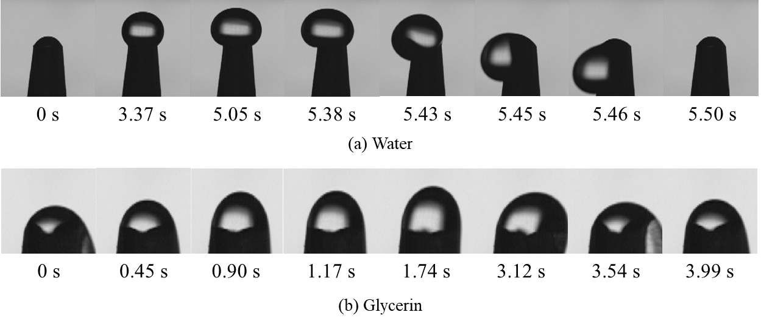
FIG. 1. Apply Figure styles.

ACKNOWLEDGEMENTS

example: This study was supported by the Space Challenge Project of NRF (National Research Foundation of Korea).

REFERENCES

[1] N.M. El-Gohary, H. Osman, and T.E. El-Diraby, Stakeholder Management for Public Private Partnerships. International Journal of Project Management. 24(7), 2006, pp. 595-604.
[2] M.M. Kumaraswamy and A.M. Anvuur, Selecting sustainable teams for PPP projects. Building and Environment. 43(6), 2008, pp. 999-1009.
[3] B. Sookie, R. Santhosh, V. Ramakrishnan, and S. Sookie, Remediation of concrete using Microorganism. ACI Materials Journal. 2001. DOI: 10.14359/10154.
[4] N.M. El-Gohary, H. Osman, and T.E. El-Diraby, Basic design aspects of micro hydro power plant and its potential development, National Proceedings of Power and Energy Conference, PECON.2004 29-30 November, 2004, IEEE 0-7803-8724-4.
[5] R.F. Fellows and A.M. Liu, Research methods for construction. 2008, Oxford, UK: John Wiley and Sons Publications.
[6] M.B. Miles, A.M. Huberman, and J. Saldana, Qualitative data analysis: A methods sourcebook. 2013, London, UK: Sage Publications.
[7] N.J. Habraken, The structure of the Ordinary, The MIT press, Cambridge MA, 2000.
[8] ProItaca, Protocollo ITACA Nazionale 2011 [Online], 2011. Available at: http://www.proitaca.org/ [Accessed 29/06/2014].

REFERENCES EXAMPLE

1) Journal Article
[1] N.M. El-Gohary, H. Osman, and T.E. El-Diraby, Stakeholder Management for Public Private Partnerships. International Journal of Project Management. 24(7), 2006, pp. 595-604.
[2] M.M. Kumaraswamy and A.M. Anvuur, Selecting sustainable teams for PPP projects. Building and Environment. 43(6), 2008, pp. 999-1009.
[3] B. Sookie, R. Santhosh, V. Ramakrishnan, and S. Sookie, Remediation of concrete using Microorganism. ACI Materials Journal. 2001. DOI: 10.14359/10154.

2) Conference
[1] N.M. El-Gohary, H. Osman, and T.E. El-Diraby, Basic design aspects of micro hydro power plant and its potential development, National Proceedings of Power and Energy Conference, PECON.2004 29-30 November, 2004, IEEE 0-7803-8724-4.

3) Book
[1] R.F. Fellows and A.M. Liu, Research methods for construction. 2008, Oxford, UK: John Wiley and Sons Publications.
[2] M.B. Miles, A.M. Huberman, and J. Saldana, Qualitative data analysis: A methods sourcebook. 2013, London, UK: Sage Publications.

4) Electronic Book
[1] N.J. Habraken, The structure of the Ordinary, The MIT press, Cambridge MA, 2000.

5) Web Page
[1] ProItaca, Protocollo ITACA Nazionale 2011 [Online], 2011. Available at: http://www.proitaca.org/ [Accessed 29/06/2014].

