JOURNAL OF SPACE SECURITY 2024, 1(1):00-00
https://doi.org/00.0000/JOSS.2024.1.1.1 ISSN (online) : 0000-0000
Research Article Open Access
Title: Font, Ocean Sans Std Semibold; Size, 15pt
First Author¹, Second Author², and Third Author¹*
¹Department of Aerospace Engineering, Seoul National University, Seoul 08826 South Korea
²Department of Aerospace Engineering, Indian Institute of Technology Madras, P.O., Chennai 600 036, India
*Corresponding author: Corresponding author e-mail
Received Monthly 00, 2024 / Revised February 00, 2024 / Accepted March 00, 2024
ABSTRACT
Abstract: Font, Minion Pro; Size, 9pt; Content style is applied.
Key Words: Font, Minion Pro; Size, 9pt; Capitalize the first letter of all keywords words.

I. INTRODUCTION

Apply body styles; Font, Minion Pro; Size, 10pt

II. MATERIALS AND METHODOLOGY

A. Subtitle: Font, Minion Pro SmBd; Size, 10pt; Location, Left
Apply body styles; Font, Minion Pro; Size, 10pt

Copyright © 2024 Korean Academy of Space Security
Ⓒ This is an Open Access article distributed under the terms of the Creative Commons Attribution Non-Commercial License (https://creativecommons.org/licenses/by-nc/4.0/) which permits unrestricted non-commercial use, distribution, and reproduction in any medium, provided the original work is properly cited.
III. RESULTS AND DISCUSSIONS

A. Subtitle: Font, Minion Pro SmBd; Size, 10pt; Location, Left
1. Smalls title: Font, Ocean Sans Std Book; Size, 10pt; Location, Left
Apply body styles; Font, Minion Pro; Size, 10pt

IV. CONCLUSION

Apply body styles; Font, Minion Pro; Size, 9.8pt
TABLE I. Apply Table styles
Working Fluids | Density  (kg/m⁻³) | Surface tension  mNm⁻¹ | Viscosity  mPa^{-s} | Conductivity  Sm⁻¹ | Relative  permittivity | Molecular weight  gmol⁻¹
Water | 1000 | 72.6 | 1 | 0.02-0.08 | 80 | 18
Glycerin | 1261 | 63.4 | 954 | 1 | 17-74.32 | 92
Indium | 7310 | 530~570 | 1.75 | 1.2Í107 | 1.13Í106 | 114.8
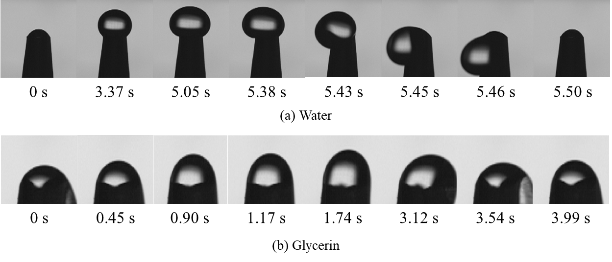
FIG. 1. Apply Figure styles.

ACKNOWLEDGEMENTS

This study was supported by the Space Challenge Project of NRF (National Research Foundation of Korea).

AUTHOR DECLARATIONS

None

CONFLICT OF INTEREST

The authors have no conflicts to disclose.

DATA AVAILABILITY

The data that support the findings of this study is included in this manuscript.

REFERENCES

[1] S. Mazouffre, “Electric propulsion for satellites and spacecraft: established technologies and novel approaches,” Plasma Sources Sci. Technol. 25, 33002 (2016).
[2] D. O’Reilly, G. Herdrich, and D.F. Kavanagh, “Electric propulsion methods for small satellites: A review,” Aerospace 8, 22 (2021).
[3] T. Henning, K. Huhn, L.W. Isberner, and P.J. Klar, “Miniaturized electrospray thrusters,” IEEE Trans. Plasma Sci. 46, 214-218 (2017).
[4] N. S. Mühlich, J. Gerger, B. Seifert, and F. Aumayr, “Performance improvements of IFM Nano Thruster with highly focused ion beam generated with a compact electrostatic lens module,” Acta Astronaut. 201, 464-471 (2022).
[5] A. Quraishi, S. Dworski, C. Ma, C.N. Ryan, A. Ferreri, G. Vincent, H. Larsen, E.R. Azevedo, E. Dingle, and A. Garbayo, “Designing and commercialization of porous emitter electrospray thruster for space applications,” in AIAA SciTech 2023 Forum (AIAA Aerospace Research Central, 2023), p. 262.
[6] L. Zhang, M. M. Bhatti, E. E. Michaelidea, and R. Ellahi, “Characterizing Quadratic Convection and Electromagnetically Induced Flow of Couple Stress Fluids in Microchannels,” Qualitative Theor. Dynamical Sys. 23(1), 35 (2024).
[7] G. I. Taylor, “Disintegration of water drops in an electric field,” Proceeding R. Sociey London. Ser. A. Math. Phys. Sci. 280, 383-397 (1964). https://royalsocietypublishing.org/.
[8] P. Kumar, C. Kwon, K. Kwon, and J. J. Yoh, “On the cone-to-jet transition region and its significance in electrospray propulsion,” Acta Astronaut. 205, 12-22 (2023).
[9] M. Cloupeau and B. Prunet-Foch, “Electrostatic spraying of liquids in cone-jet mode,” J. Electrostat. 22, 135-159 (1989).
[10] R. Juraschek and F. W. Röllgen, “Pulsation phenomena during electrospray ionization,” Int. J. Mass Spectrom. 177, 1-15 (1998).
[11] A. Ramos, Electrokinetics and electrohydrodynamics in microsystems (Springer, 2011).
[12] J. Rosell-Llompart, J. Grifoll, and I. G. Loscertales, “Electrosprays in the cone-jet mode: From Taylor cone formation to spray development,” J. Aerosol Sci. 125, 2-31 (2018).
[13] P. Wright, A. Thuppul, and R. E. Wirz, “Life-limiting emission modes for electrospray thrusters,” in 2018 Joint Propulsion Conference (AIAA, 2018), p. 4726.

